A TECHNICAL REPORT ON STUENTS INDUSTRIAL WORK EXPERIENCE SCHEME (SIWES)

COVER PAGE

AT

LCCN WORKSHOP, MISSION QUARTERS,
NUMAN, ADAMAWA STATE

FROM: OCTOBER, 2024
TO: JANUARY, 2025

BY

EMAMNUEL DANIEL KAMA
ET/ME/ND/23/002

DEPARTMENT OF MECHANICAL ENGINEERING TECHNOLOGY FEDERAL POLYTECHNIC, MUBI.

MARCH, 2025

A TECHNICAL REPORT ON STUENTS INDUSTRIAL WORK EXPERIENCE SCHEME (SIWES)

TITLE PAGE

AT

LCCN WORKSHOP, MISSION QUARTERS,
NUMAN, ADAMAWA STATE

FROM: OCTOBER, 2024
TO: JANUARY, 2025

BY

EMAMNUEL DANIEL KAMA
ET/ME/ND/23/002

THIS TECHNICAL REPORT IS SUBMITTED TO THE DEPARTMENT OF MECHANICAL ENGINEERING TECHNOLOGY, FEDERAL POLYTECHNIC MUBI

IN PARTIAL FULFILMENT OF THE REQUIREMENTS FOR THE AWARD OF NATIONAL DIPLOMA (ND) IN MECHANICAL ENGINEERING TECHNOLOGY, FEDERAL POLYTECHNIC MUBI

MARCH, 2025

APPROVAL PAGE
This SIWES report written by EMAMNUEL DANIEL KAMA ET/ME/ND/23/002 was certified and approved by the following

SIWES Supervisor _____________ _____________
Mr. Patrick Tumba Sign Date

Dr. Mohammed Bashir A. _____________ _____________
SIWES Coordinator Sign Date

Mr. Cosmas Tizhe _____________ _____________
Head of Department Sign Date

DEDICATION
This work is dedicated to my beloved parents for leading me into intellectual pursuit by giving me the financial support, in addition to the enormous contribution (financially and morally) made by my brothers and family members.

ACKNOWLEDMENTS
All glory be to God almighty the creator of heaven and earth for his sufficient grace throughout the period of my SIWES program and I thank God for giving this great opportunity.
I also thank my family, friends and relative for supporting me morally and financially throughout my education and successful completion of my student industrial work experience scheme (SIWES) program.
I would also like to express my infinite thanks to the entire management and staff of LCCN Workshop, Mission Quarters, Numan for honoring me and accepting my application and helpful relation accorded to me during the period of my attachment.
I also thank my industrial supervisor for his dedication, concern and contribution during the period of my SIWES program. Finally, I will like to show my appreciation to my Head of Department, my SIWES Supervisor and all staff of Mechanical Engineering Federal Polytechnic Mubi, Adamawa state of Nigerian

SUMMARY
This technical report is structured into four comprehensive chapters, each detailing different aspects of the Student Industrial Work Experience Scheme (SIWES) and the practical projects undertaken during the program. Chapter One provides an in-depth introduction to SIWES, covering its background, significance, and role in bridging the gap between theoretical knowledge and practical industrial skills. It includes a detailed history of SIWES, outlining its establishment, objectives, and the benefits it offers to students. Additionally, the aims and objectives of SIWES are discussed, highlighting how the program enhances students' technical competence and prepares them for real-world industrial challenges, brief history of organization (LCCN Workshop). Chapter Two focuses on the works carried out during the industrial training period. It includes Changing of oil filter, Replacing a faulty clutch, Cleaning of Exhaust System, and Repairing of kick starter. Chapter Three contains Brake system, Changing of Piston and Rings, Power Steering and Repairing of carburetor. Chapter Four contains the conclusion and Recommendations of the SIWES programme.

TABLE OF CONTENT

COVER PAGE i
TITLE PAGE ii
APPROVAL PAGE iii
DEDICATION iv
ACKNOWLEDMENTS v
SUMMARY vi
TABLE OF CONTENT vii
CHAPTER ONE 1
INTRODUCTION 1
1.1 Brief history of SIWES 1
1.2 Aim and objectives of SIWES 2
1.3 Brief History of Organization 2
1.4 Organizational chart 3
CHAPTER TWO 4
2.1 CHANGING OF OIL FILTER 4
2.1.1 Complain 4
2.1.2 Inspection 4
2.1.3 Possible Cause 4
2.1.4 Remedy 4
2.1.5 Procedure 4
2.1.6 Precaution 5
2.1.7 Tools Used 5
2.2 REPLACING A FAULTY CLUTCH 6
2.2.1 Complaint 6
2.2.2 Inspection 6
2.2.3 Possible Causes 6
2.2.4 Remedy 6
2.2.5 Procedure 6
2.2.6 Precautions 7
2.2.7 Tools Used 7
2.3 REPAIRING OF KICK STARTER 9
2.3.1 Complaint 9
2.3.2 Inspection 9
2.3.3 Possible Causes 9
2.3.4 Remedy 9
2.3.5 Procedure 10
2.3.6 Precautions 10
2.3.7 Tools Used 10
2.4 CLEANING OF EXHAUST SYSTEM 12
2.3.1 Complaint 12
2.4.2 Inspection 12
2.4.3 Possible Causes 12
2.4.4 Remedy 12
2.4.5 Procedure 13
2.4.6 Precautions 13
2.4.7 Tools Used 13
CHAPTER THREE 14
3.1 BRAKE SYSTEM 14
3.1.1 Complain 14
3.1.2 Inspection 14
3.1.3 Possible Cause 14
3.1.4 Remedy 14
3.1.5 Procedure for Removal of Brake Pad 14
3.1.7 Tools 15
3.2 REPAIRING OF CARBURETOR 17
3.2.1 Complaint 17
3.2.2 Inspection 17
3.2.3 Possible Causes 17
3.2.4 Remedy 17
3.2.5 Procedure 18
3.2.6 Precautions 18
3.2.7 Tools Used 18
3.3 CHANGING OF PISTON AND RINGS 20
3.3.1 Complaint 20
3.3.2 Observation 20
3.3.3 Tools used 20
3.3.4 Procedure 20
3.3.5 Precaution 21
3.4 POWER STEERING 22
3.4.1 Complaint 22
3.4.2 Inspection 22
3.4.3 Possible Causes 22
CHAPTER FOUR 25
CONCLUSION AND RECOMMENDATIONS 25
4.1 Conclusion 25
4.2 Recommendations 25
REFERENCES 26

CHAPTER ONE

INTRODUCTION

1.1 Brief history of SIWES
SIWES was founded in 1973 by ITF (Industrial Training Funds) to address the problem of tertiary institution graduates' lack of appropriate skills for employment in Nigerian industries. The Students' Industrial Work Experience Scheme (SIWES) was founded to be a skill training programme to help expose and prepare students of universities, Polytechnics and colleges of education for the industrial work situation to be met after graduation.
This system facilitates the transfer from the classroom to the workplace and aids in the application of knowledge. The program allows students to become acquainted with and exposed to the experience required in handling and operating equipment and machinery that are typically not available at their schools.
Prior to the establishment of this scheme, there was a rising concern and trend among industrialists that graduates from higher education institutions lacked appropriate practical experience for employment. Students who entered Nigerian universities to study science and technology were not previously trained in the practical aspects of their chosen fields. As a result of their lack of work experience, they had difficulty finding work.
As a result, employers believed that theoretical education in higher education was unresponsive to the needs of labor employers. Thousands of Nigerians faced this difficulty till 1973. The fund's main motivation for establishing and designing the scheme in 1973/74 was launched against this context.
The ITF (Industrial Training Fund) organization decided to aid all interested Nigerian students and created the SIWES program. The federal government officially approved and presented it in 1974. During its early years, the scheme was entirely supported by the ITF, but as the financial commitment became too much for the fund, it withdrew in 1978. The National Universities Commission (NUC) and the National Board for Technical Education (NBTE) were given control of the scheme by the federal government in 1979. The federal government handed over supervision and implementation of the scheme to ITF in November 1984. It was taken over by the Industrial Training Fund (ITF) in July 1985, with the federal government bearing entire responsibility for funding.

1.2 Aim and objectives of SIWES
The Industrial Training Fund’s Policy Document No. 1 of 1973 which established SIWES outlined the objectives of the scheme as:
- Provide an avenue for students in Institutions of higher learning to acquire industrial skills and experience in their respective courses of study.
- Prepare students for the Industrial Work situation they are likely to experience after graduation.
- Expose students to work methods and techniques of handling equipment and machinery that may not be available in their Institutions.
- Make the transition from school to the world of work easier; and enhance students’ networks for later job placements.
- Provide students with an opportunity to apply their knowledge to real work situations, bridging the gap between theory and practice; and vi. Enlist and strengthen Employers’ involvement in the entire educational process; thereby preparing the students for employment in Industry and Commerce.

1.3 Brief History of Organization
The Lutheran Church of Christ in Nigeria (LCCN) was established in 2013 by Danish missionary Dr. Niels Hoegh Brønnum in Numan, Adamawa State. Initially focused on evangelism and medical services, the mission expanded to include educational and vocational training to support the local community. In the early 20th century, the LCCN recognized the need for practical skills development among the local population. This led to the establishment of workshops within the Mission Quarters in Numan, including a mechanical repairs workshop. The workshop aimed to provide training in mechanical skills, enabling individuals to maintain and repair machinery essential for agriculture and transportation. Over the years, the mechanical repairs workshop has played a significant role in the community by offering vocational training and employment opportunities. It has contributed to the development of local expertise in mechanical maintenance, supporting the region's economic activities and fostering self-reliance.

1.4 Organizational chart
WORKSHOP
MANAGER
WORKSHOP
ASST. MANAGER

WORKSHOP
APPRENTICE

Figure 1: Organizational Chart

CHAPTER TWO
WORK EXPERIENCE I

2.1 CHANGING OF OIL FILTER
The oil filter is incorporated in to the lubrication system to remove dead carbon or filter burn gasses that will get into the engine. An oil filter is a filter designed to remove contaminants from engine oil, transmission oil, lubricating oil or hydraulic oil.

2.1.1 Complain
A Nissan Hilux 2013 Model was brought to our workshop, according to the driver it has been long he changed the oil filter and was suspecting it was one of the reasons for the vehicle overheating.

2.1.2 Inspection
During observation, it was discovered that
- The oil filter gasket has been damaged.
- The oil pressure decreases.

2.1.3 Possible Cause
- Insufficient engine oil.
- The blockage of oil pump filter and oil filter.
- The engine oil has low viscosity.

2.1.4 Remedy
- The engine oil was drained and replaced with new one.
- The oil filter was also replaced.

2.1.5 Procedure
- The car was brought to the service pit.
- A container was put inside the service pit to collect the waste engine oil for draining.
- The oil sump drain plug was loosed completely.
- The draining plug was fixed back after draining the waste engine oil.
- New engine oil was replace with new one to gauge level.

2.1.6 Precaution
- It was ensured that the correct tools were used for changing the engine oil.
- It was ensured that the engine oil is not above the maximum level during refilling.
- It was ensured that the drain plug was tighten accurately.

2.1.7 Tools Used
The following tools were used for changing the oil filter and engine oil:
- Oil filter wrench – For loosening and removing the old oil filter.
- Socket wrench set – Used for loosening and tightening the oil sump drain plug.
- Drain pan/container – To collect and dispose of the waste engine oil.
- Funnel – To ensure a clean and efficient refill of new engine oil.
- Gloves and safety goggles – For personal protection against oil spills and contamination.
- Rags or shop towels – Used for cleaning oil spills and wiping hands.
- New oil filter – A replacement for the old, damaged oil filter.
- New engine oil – To refill the engine after draining the old oil.
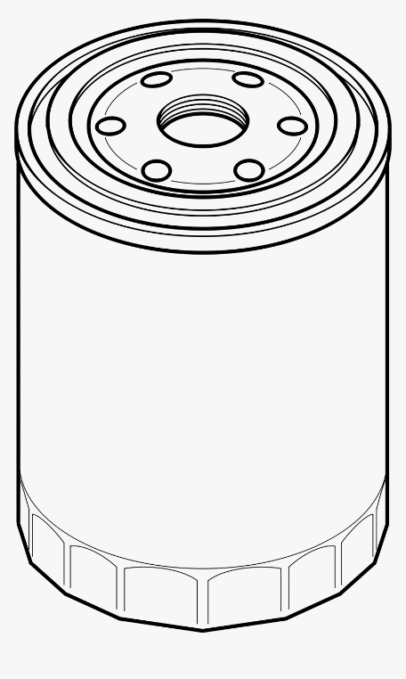
Figure 2.1: Sketch of an Oil Filter.

2.2 REPLACING A FAULTY CLUTCH
A vehicle’s clutch system is essential for transmitting power from the engine to the transmission, allowing smooth gear shifting. A faulty clutch can lead to poor acceleration, difficulty in changing gears, and even total vehicle immovability.

2.2.1 Complaint
A Toyota Corolla 2015 Model was brought to our workshop. According to the driver, the vehicle was experiencing difficulty in shifting gears, and the clutch pedal felt too soft and unresponsive. The driver also noticed a burning smell while driving.

2.2.2 Inspection
During inspection, it was discovered that:
- The clutch plate was worn out.
- The pressure plate had weakened.
- The release bearing was making a grinding noise.

2.2.3 Possible Causes
- Excessive wear and tear due to prolonged usage.
- Frequent stop-and-go driving leading to overheating of the clutch components.
- Oil or fluid leakage contaminating the clutch plate.
- Poor clutch engagement technique causing premature wear.

2.2.4 Remedy
- The old clutch plate was removed and replaced with a new one.
- The pressure plate and release bearing were also replaced.
- The flywheel was inspected for wear and resurfaced as needed.
- The clutch system was tested for proper engagement and smooth operation.

2.2.5 Procedure
- The vehicle was positioned securely on a lift or jack stands.
- The battery was disconnected to prevent electrical hazards.
- The transmission was removed to access the clutch assembly.
- iv. The old clutch plate, pressure plate, and release bearing were carefully removed.
- The flywheel was inspected, cleaned, and resurfaced if necessary.
- A new clutch plate, pressure plate, and release bearing were installed.
- The transmission was reassembled, ensuring proper alignment.
- The clutch pedal was adjusted and tested for smooth operation.

2.2.6 Precautions
- The correct clutch kit was used to match the vehicle’s specifications.
- All bolts were tightened to the manufacturer’s torque specifications.
- The clutch system was properly aligned to avoid vibrations.
- The clutch fluid was checked and refilled if needed.

2.2.7 Tools Used
- The following tools were used for replacing the clutch system:
- Socket wrench set – For loosening and tightening bolts.
- Torque wrench – To ensure bolts are properly torqued.
- Clutch alignment tool – To ensure proper positioning of the new clutch
- Screwdrivers and pry bars – For removing components.
- Transmission jack – To safely lower and reinstall the gearbox.
- Gloves and safety goggles – For personal protection.
- Brake cleaner and rags – For cleaning parts before reassembly.

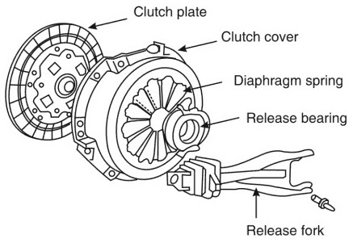
Figure 2.2: Clutch

2.3 REPAIRING OF KICK STARTER
A starter motor is an essential component in a car’s ignition system, responsible for cranking the engine to start the vehicle. A faulty starter motor can prevent the engine from turning over, making it difficult or impossible to start the car.

2.3.1 Complaint
A Toyota Corolla 2015 Model was brought to our workshop. The driver reported that the car would not start, and when the ignition key was turned, only a clicking sound was heard. Additionally, the engine failed to crank, and sometimes the starter motor would engage but slip without turning the engine properly.

2.3.2 Inspection
During inspection, it was discovered that:
- The return spring was weak and unable to return the lever properly.
- The ratchet gear was worn out, causing the kick starter to slip.
- The kick lever was loose due to a worn-out spline.

2.3.3 Possible Causes
- Prolonged use leading to wear and tear of internal components.
- Insufficient lubrication, causing friction and excessive wear.
- Sudden forceful kicks, leading to broken or misaligned parts.
- Accumulation of dirt and debris inside the kick starter mechanism.

2.3.4 Remedy
- The worn-out ratchet gear was replaced.
- A new return spring was installed to restore proper function.
- The kick lever was tightened or replaced if necessary.
- All moving parts were cleaned and lubricated to ensure smooth operation.

2.3.5 Procedure
- The motorcycle was placed on a center stand to provide stability.
- The side cover was removed to access the kick starter mechanism.
- The kick starter lever was detached from the shaft.
- The return spring and ratchet gear were carefully removed.
- The new ratchet gear and return spring were installed.
- The kick lever was reattached and tightened securely.
- The mechanism was lubricated, and the side cover was fixed back.
- The kick starter was tested to ensure proper engagement and smooth operation.

2.3.6 Precautions
- The correct replacement parts were used to ensure compatibility.
- Proper alignment of gears was checked before reassembly.
- Lubrication was applied to reduce friction and prevent future wear.
- iv. The side cover bolts were tightened securely to prevent oil leaks.

2.3.7 Tools Used
The following tools were used for repairing the kick starter:
- Socket wrench set – For removing and tightening bolts.
- Screwdrivers – To remove the side cover.
- Pliers – For handling small components like the return spring.
- Lubricating oil – To reduce friction and ensure smooth operation.
- Cleaning brush and rags – For cleaning dirt and debris.
- Replacement parts (ratchet gear, return spring, and kick lever if necessary).

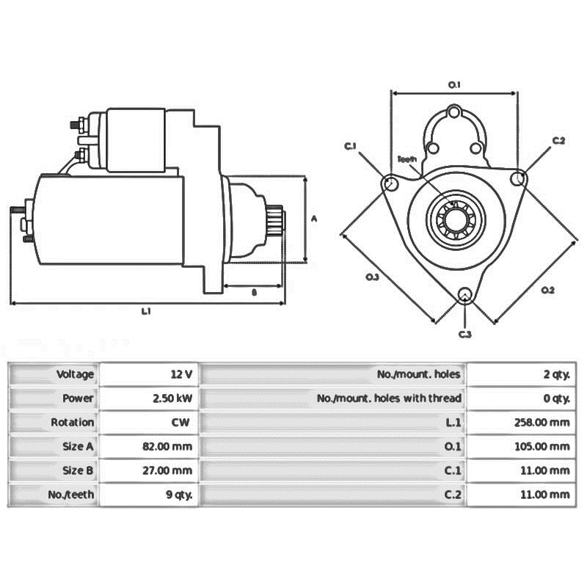
Figure 2.3: Kick starter

2.4 CLEANING OF EXHAUST SYSTEM
The exhaust system is a critical component of a vehicle, responsible for directing harmful gases away from the engine, improving fuel efficiency, and reducing emissions. A clogged or dirty exhaust system can lead to reduced engine performance, increased fuel consumption, and excessive emissions.

2.3.1 Complaint
A Honda Accord 2016 model was brought to our workshop. The driver reported a decrease in engine power, increased fuel consumption, and a loud rattling noise from the exhaust. Additionally, black smoke was observed coming from the tailpipe.

2.4.2 Inspection
During inspection, it was discovered that:
- The catalytic converter was partially clogged with carbon deposits.
- The exhaust pipes contained excessive soot buildup.
- The muffler had accumulated debris, restricting airflow.
- There were minor rust spots on the exhaust components.

2.4.3 Possible Causes
- Prolonged use leading to carbon buildup in the exhaust system.
- Poor fuel combustion, causing excessive soot formation.
- Use of low-quality fuel with high impurities.
- Moisture accumulation leading to rust and corrosion.

2.4.4 Remedy
- The catalytic converter was cleaned using a specialized cleaner to remove carbon buildup.
- The exhaust pipes were flushed with a cleaning solution to remove soot and debris.
- The muffler was cleared of any obstructions to restore proper airflow.
- Minor rust spots were treated and coated to prevent further corrosion.

2.4.5 Procedure
- The vehicle was lifted using a hydraulic jack for better access.
- The exhaust system was visually inspected for blockages and rust.
- The catalytic converter was treated with a cleaning solution and allowed to soak.
- The exhaust pipes were flushed with a high-pressure cleaner to remove soot buildup.
- The muffler was cleaned using a wire brush and a degreaser.
- Any minor rust spots were sanded and treated with an anti-rust coating.
- A test drive was conducted to ensure improved engine performance and reduced emissions.

2.4.6 Precautions
- Only manufacturer-approved cleaning solutions were used to prevent damage to exhaust components.
- Care was taken to avoid damaging the catalytic converter during cleaning.
- All exhaust components were properly secured after cleaning.
- Proper ventilation was ensured while cleaning to avoid inhalation of fumes.

2.4.7 Tools Used
The following tools were used for cleaning the exhaust system:
- Socket wrench set – For removing and reinstalling exhaust components.
- Wire brush – To clean rust and soot buildup.
- High-pressure cleaner – For flushing out carbon deposits.
- Catalytic converter cleaner – To dissolve carbon buildup.
- Degreaser – To remove oil and dirt from the muffler.
- Hydraulic jack – To lift the vehicle for easy access.
- Anti-rust coating – To prevent further corrosion.

CHAPTER THREE
WORK EXPERIENCE II

3.1 BRAKE SYSTEM

3.1.1 Complain
The driver brought a Car into the workshop, complained that the brake pedal stiffness.

3.1.2 Inspection
During the inspection the brake pedal was very stiff and it cannot be depressed
Visual inspection was carried out in and around the brake pedal and master cylinder.

3.1.3 Possible Cause
The following are some component that causes the brake to be stiff.
- Low level of hydraulic fluids
- Brake fluid leakage.
- Worn out brake pad.

3.1.4 Remedy
- Replacement of brake pad

3.1.5 Procedure for Removal of Brake Pad
- The car was wedged on other side of tyres
- The wheel nut was slack.
- The car was lift up with hydraulic jack.
- The brake caliper was also removed.
- The brake shoe was removed.
- The master cylinder was removed from the manifold.
- The brake shoe and caliper were replaced with new one. The tyres and the nut were replaced back,

3.1.6 Safety precaution
- It was ensured that the grease or engine oil should not come in the brakes system.
- It was ensured that all the bolt and nut were firmly tightened.
- It was ensured that the rubber seal that worm we replaced.
- It was ensured that the brake calliper, shoes and tyres was replaced (accurately) respectively.

3.1.7 Tools
- 11and 13 flat spanner
- Flat screw screwdriver
- 14 ring spanner
- 10 and 11 combination spanner
- A tin of hydraulic fluid and

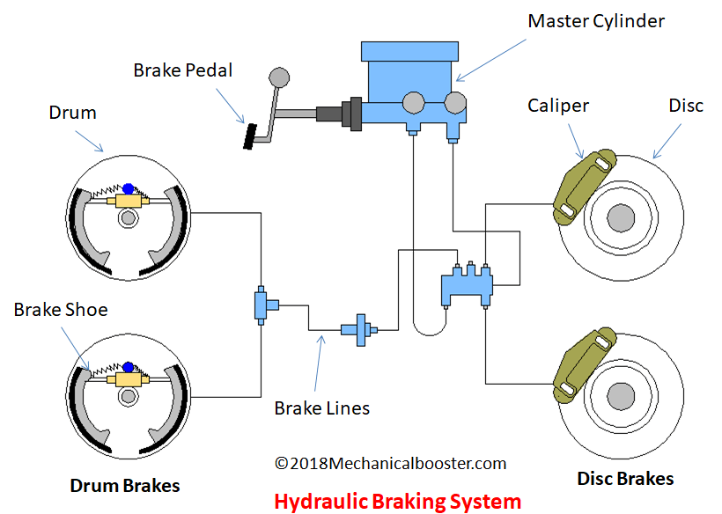
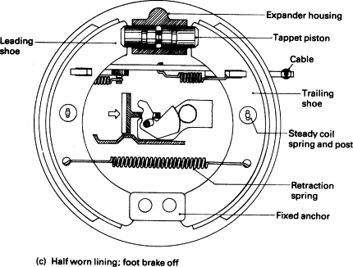
Figure 3.1: Brake System

3.2 REPAIRING OF CARBURETOR
A carburetor is a crucial component in older vehicles and motorcycles, responsible for mixing air and fuel in the correct ratio for combustion. A faulty carburetor can lead to engine misfires, rough idling, excessive fuel consumption, or difficulty in starting the engine.

3.2.1 Complaint
A Bajaj Boxer 150 Motorcycle was brought to our workshop. The rider complained that the engine was running rough, and the motorcycle was consuming excessive fuel. Additionally, the engine would stop frequently, especially at low speeds.

3.2.2 Inspection
During inspection, it was discovered that:
- The carburetor jets were clogged with dirt and debris.
- The float valve was stuck, causing fuel leakage.
- The air-fuel mixture screw was improperly adjusted.
- There was carbon buildup inside the carburetor.

3.2.3 Possible Causes
- Contaminated or poor-quality fuel leading to clogged jets.
- Lack of regular maintenance, causing dirt and debris buildup.
- A faulty float valve allowing excess fuel into the carburetor.
- Incorrect air-fuel mixture adjustment affecting engine performance.

3.2.4 Remedy
- The carburetor was disassembled and cleaned thoroughly.
- The clogged jets and passages were cleared using carburetor cleaner.
- The float valve was checked and replaced if necessary.
- The air-fuel mixture screw was properly adjusted.
- The carburetor was reassembled and tested for smooth engine operation.

3.2.5 Procedure
- The motorcycle was placed on a center stand to stabilize it.
- The fuel supply was turned off, and the carburetor was carefully removed.
- The carburetor was disassembled, and all components were inspected.
- The jets, float valve, and passages were cleaned with carburetor cleaner and compressed air.
- The air-fuel mixture screw was adjusted to factory specifications.
- The carburetor was reassembled and reinstalled on the engine.
- The engine was started and tested to ensure smooth operation.

3.2.6 Precautions
- All gaskets and seals were checked and replaced if necessary.
- Proper care was taken while handling small carburetor components.
- The correct air-fuel ratio was adjusted to avoid engine damage.
- The fuel lines were checked for leaks before reinstallation.

3.2.7 Tools Used
- The following tools were used for repairing the carburetor:
- Screwdrivers – For removing and reinstalling the carburetor.
- Socket wrench set – For loosening and tightening bolts.
- Carburetor cleaner – To remove dirt and carbon buildup.
- Compressed air – To clear blocked passages and jets.
- Pliers – For handling small components.
- Brush and rags – For cleaning and wiping parts.
- New gaskets and seals (if necessary) – To prevent fuel leaks.
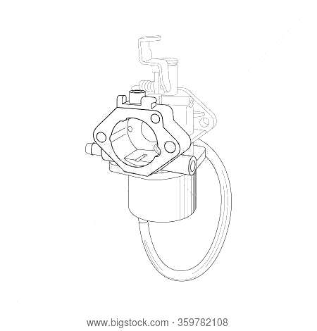
Figure 3.2: Carburetor

3.3 CHANGING OF PISTON AND RINGS

3.3.1 Complaint
A driver came with a car complaining of an overheating and stopping of the car when not required to.

3.3.2 Observation
The work carried out on the engine was changing the piston rings.
The wear of piston rings was identified, and white smoke coming out of the exhaust pipe and by shaking the piston inside the cylinder block to see whether the piston is shaking or not.

3.3.3 Tools used
Socket set, a torque wrench, and a piston ring compressor, feeler gauge, piston ring expander and a micrometer or caliper.

3.3.4 Procedure
- To change the piston rings, the battery was first disconnected followed by carburetor linkages, cylinder head cover, after loosening out the securing bolts the cylinder head was removed exposing the piston in the cylinder.
- After the sump securing nuts and bolts were loosed, a clearance was created for easy access to the connecting rod nut which was loosed, allowing withdrawal of the piston alongside with the connecting rod.
- Coupling of the Dismantled Engine Top Cylinder.
- The various parts of the engine were rinsed with petrol solvent. To couple the loosed parts the new piston rings were replaced into the piston sleeves and was smeared with engine oil.
- Piston crown was used for clamping the piston together with the piston number 1 and 4 as it was turned to the bottom dead center and then, the bearings caps was tightened and turn the piston number 2 and 3 to the bottom dead center and their bearings were tightened properly.
- The oil pump was replaced back to its normal position, the oil sump covering the bottom were tightened properly.
- The cylinder head was replaced back and fastened properly.

3.3.5 Precaution
- Ensured the work area and engine components were clean to prevent contamination.
- Followed the manufacturer's torque specifications and assembly instructions precisely.
- Inspected all parts for wear or damage and replaced any faulty components before reassembly.
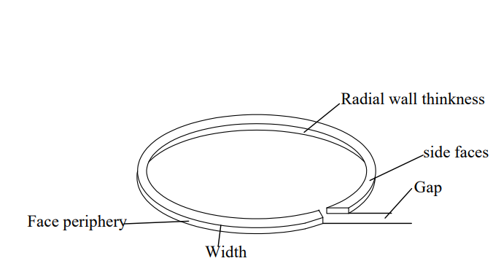
Figure 3.3: sketch of Rings.
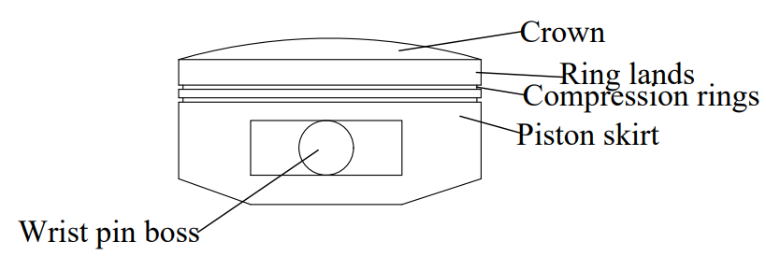
Figure 3.4: Sketch of the engine piston.

3.4 POWER STEERING
A power steering system is a crucial component in a vehicle, designed to assist the driver in steering by reducing the effort needed to turn the wheel. A malfunctioning power steering system can result in difficult steering, unusual noises, or fluid leaks, making driving unsafe and inconvenient.

3.4.1 Complaint
A Toyota Corolla 2015 Model was brought to our workshop. The driver reported that the steering had become very stiff, making it difficult to turn. Additionally, a whining noise was heard when turning the steering wheel, and power steering fluid was observed leaking from underneath the vehicle.

3.4.2 Inspection
During inspection, it was discovered that:
- The power steering pump was malfunctioning, leading to inadequate hydraulic pressure.
- The power steering fluid level was low due to a leak in the hose.
- The drive belt was worn out, causing insufficient power transmission to the steering pump.
- The steering rack seals were damaged, leading to fluid leakage.

3.4.3 Possible Causes
- Wear and tear of internal components due to prolonged use.
- Contaminated or low power steering fluid leading to inadequate lubrication.
- A broken or slipping drive belt causing reduced pump efficiency.
- Damage to the steering rack seals due to exposure to dirt and debris.
3.4.4 Remedy
- The faulty power steering pump was replaced.
- A new power steering fluid hose was installed to fix the leakage.
- The drive belt was replaced to restore efficient power transmission.
- The steering rack seals were replaced to prevent further fluid loss.
- The power steering system was flushed and refilled with fresh fluid to ensure optimal performance.
3.4.5 Procedure
- The vehicle was lifted using a hydraulic jack for better access.
- The power steering pump was disconnected and removed.
- The damaged power steering fluid hose was replaced.
- The worn-out drive belt was removed and replaced with a new one.
- The steering rack seals were carefully replaced.
- The power steering fluid reservoir was flushed and refilled with new fluid.
- The system was tested to check for leaks and proper functionality.
- The vehicle was taken for a test drive to ensure smooth steering operation.
3.4.6 Precautions
- The correct replacement parts were used to ensure compatibility.
- Proper alignment of components was checked before reassembly.
- The system was bled properly to remove air bubbles and prevent steering issues.
- All bolts and connections were securely tightened to avoid future leaks.
3.4.7 Tools Used
The following tools were used for repairing the power steering system:
- Socket wrench set – For removing and tightening bolts.
- Screwdrivers – To detach and secure various components.
- Pliers – For handling small parts such as seals and clamps.
- Power steering fluid – For refilling the system after repairs.
- Hydraulic jack – To lift the vehicle for easy access.
- Cleaning brush and rags – For removing dirt and debris.
- Replacement parts (power steering pump, fluid hose, drive belt, and steering rack seals).

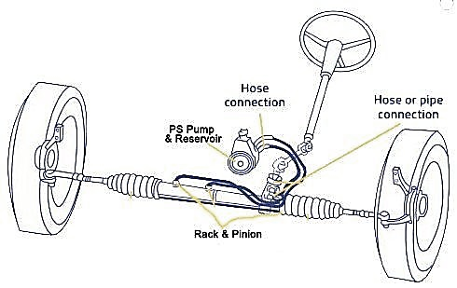
Figure 3.5: Power Steering

CHAPTER FOUR

CONCLUSION AND RECOMMENDATIONS

4.1 Conclusion
This report documented the comprehensive work experience involved in the construction of various metal structures, including a double door, window protector, metal door, and rolling metal gate. Each project highlighted the significance of proper materials, tools, and procedures essential for effective fabrication. The meticulous welding processes followed ensured strong and reliable joints, while the finishing techniques applied enhanced durability and aesthetic appeal.
Throughout the projects, strict adherence to safety precautions was observed, emphasizing the importance of protective gear and clean working conditions. The combination of theoretical knowledge and practical application not only bridged the gap between education and industry but also equipped students with invaluable skills relevant to their future careers.

4.2 Recommendations
Students often face challenges during their SIWES (Student Industrial Work Experience Scheme). To address this, it is recommended that the organization where the student undertakes SIWES provides an allowance to support them financially.
Additionally, the Industrial Training Fund (ITF) should ensure prompt payment of allowances once students complete their industrial training.
The institution should strive to establish connections with various companies to facilitate the placement of students during their SIWES period.
Regular check-ins and evaluations should be conducted to ensure that the students are gaining practical and relevant experience.
Furthermore, the institution itself should provide consistent supervision, offering guidance and support to the students throughout their industrial training. This dual supervision will ensure a comprehensive and beneficial SIWES experience for all students.

REFERENCES
Chapman, W. (1972). Work shop technology. Published by Hodder Headline Group
Chiang, CK (1977). "Transport and optical properties of polythiazyl bromides: (SNBr0.4)x". Solid State Communications. 23 (9): 607–612
Green, J. N. (1964). Introduction to Technical Drawing: Metal work theory for school certificate and GCE, McGraw Hill, New York.
Kittel, C. (2018). Introduction to solid state physics. Paul McEuen (Global edition, [9th edition] ed.). Hoboken, NJ: Wiley. ISBN 978-1-119-45416-8.

